The Creative Commons-Attribution-Noncommercial License 4.0 International applies to all works published by IASSIST Quarterly. Authors will retain copyright of the work and full publishing rights.

Template for authors of the IASSIST Quarterly – Place Title Here
Ofira Schwartz and Michele Hayslett

Abstract
This is a template for authors of the IASSIST Quarterly (IQ); its purpose is to ease the processing of submissions to the journal. The template is in Microsoft Word format and can be used by the author by overwriting the content. Authors can copy their text ('insert without formatting') into this document and then afterwards apply the formats of paragraphs and headings, and deleting the original text of the template.
If you have special requirements or questions do not hesitate to contact the editor (editor.iassistquarterly@gmail.com).

Keywords
template, author, IASSIST Quarterly, journal submission

Introduction
Submission to the IASSIST Quarterly (IQ) is performed by uploading the paper on the IQ website (https://iassistquarterly.com/) which is an Open Journal System supported by the University of Alberta. If you have not registered on the website you have to do that first. When you submit you are asked to enter title, abstract, keywords, and author(s). Remember to enter information about all authors.
Submitted papers are expected in Microsoft Word document file format and the current template document provides information about the style and format requirements.
An acknowledgement mail will be sent to the author after having submitted a paper for the IQ. Information about the review of the article can be expected within 6 weeks. We are using 'Anonymous Reviewer / Disclosed Author' so you should not produce an anonymized version of the paper. The non-special issues of the IQ are filled by first-come-first-served. So no deadlines! Furthermore, it should be noted that reviews and the amount of revision and the number of revisions have a great variance.
Most important is that you are presenting something of interest for the IASSIST commnunity and something novel. A good start is ’So far as I am aware, very little work has been done on this subject´ (Frankfurt, 2005, p. 3).

The numbered list
When you are following the guidelines shown here this facilitates the processing of your submission.

Submission at https://iassistquarterly.com
- You login at the top right corner at 'Login'
- If you have not yet registered on the website you have to do that first. Also top right at 'Register'.
- From the front page you choose 'About' and in the drop-down menu you choose 'Submission'.
- The new page includes a 'Submission Preparation Checklist' and you can also download this template under 'Author Guidelines. At the top of the page you click on 'Make a new submission'.
- When you submit you can paste some sections from your document:
  - title (sentence case capitalization)
  - abstract (maximum 250 words)
  - keywords (3-6)
  - author(s). Remember to enter information about all authors.

Basics for the submitted document
The easy way to obtain a correct formatting of your submission is to copy your text (by using 'insert without formatting') into this template document and then afterwards apply the formats of paragraphs and headings. Below is a screenshot showing the styles:
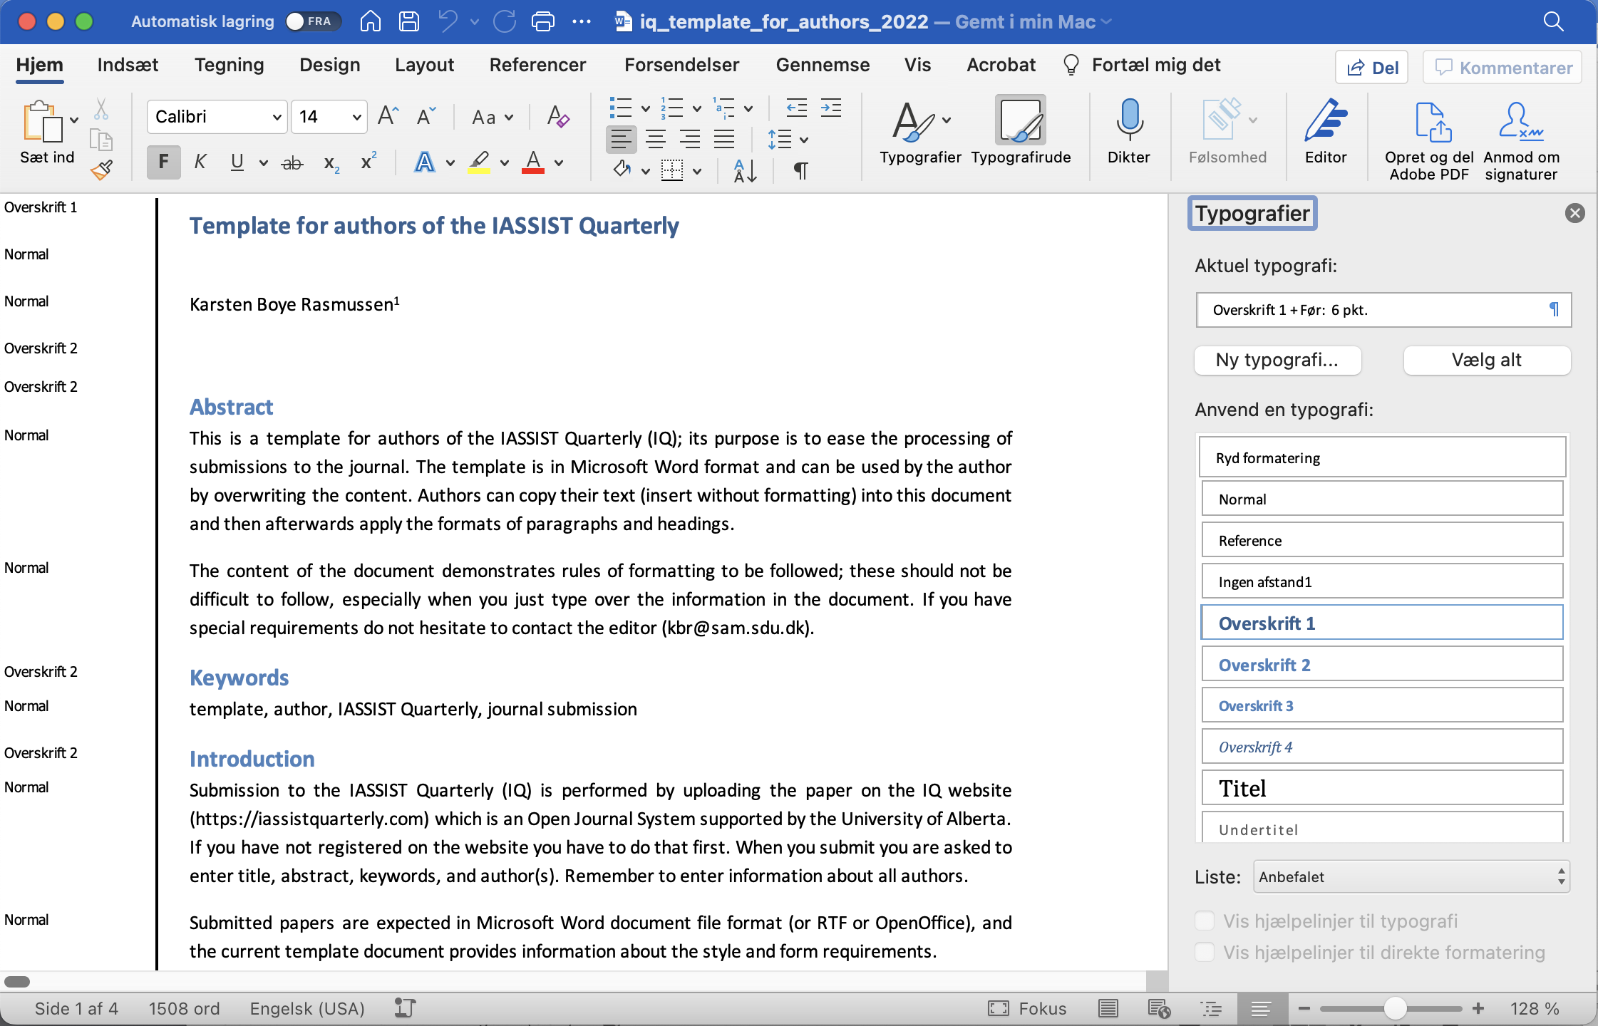
The top of the first page should contain the article title. IQ uses sentence case capitalization.
The title is followed by the author's name / authors' names.
Author(s) and title is also part of the page footer that on each page shows the reference for the article. Of couse you cannot decide the additional information: volume, issue, year, and DOI. These will be edited to the correct information later in the process. By having inserted a page footer like the one presented in this template you will know in advance where pageshifts will be placed.
Further information about the author(s) such as affiliation, address and email should be included as the first endnote(s). There should always be contact information for at least one of the authors. The contact author is for readers to contact and does not have to be the same as the author that the IQ editor is corresponding with. It is the responsibility of the corresponding author to inform co-authors about reviews and status of the submission.
Articles should begin with an abstract (max 250 words).
Keywords follow the abstract: 3-6 keywords of the author’s choice.
Articles are normally about 2000-7000 words.
We are publishing on the web and sans serif fonts work best so we are using Calibri size 11 in the regular text paragraphs.
Please refrain from use of bold or underline in the text paragraphs. Use of italics is not prohibited. (Underline is reserved for web links).
Use only one type of quotation marks and preferably the single quotation mark for both start and end: ‘like this‘.

Headings
Headings are used for Abstract, Keyword, References, Endnotes and the separation of text into sections. In Microsoft Word, please use Styles to apply Header 1 (to the title only); Header 2 (to the main segments only: Abstract, Keyword, References and Endnotes and high level sections, e.g., Introduction); and Header 3 (to lower level sections). This enables navigation by the headings and automatically nests the headings appropriately, a boon for those reading our articles via screen-reader software.
Bold and larger size fonts are to be used in headings. Two levels of headings should normally suffice. Please make the types of headings easily distinguishable by using bold&size14 (heading 1, only for the paper title) and bold&size13 (heading 2) and bold&size11 (heading 3).
Titles of headings can include numbering, with sequential numbering of lower level headings as well (e.g. ’1. Heading,’ ’1.1 Subheading’).

Notes
Footnotes placed at the foot of the page are not used. Instead please use endnotes.
Endnotes: authors are asked to use only numeric endnotes and to keep them to a minimum. The Endnotes section should follow the References section. If you by mistake have made footnotes these can in Microsoft Word be transformed into endnotes. Beware that Google Doc might display Word endnotes incorrectly.

References
Bibliographic citations should be consistent in style following the Harvard standard (author, year) in the text paragraphs. You can google many instructions for this standard e.g. the instructions from the University of Stafford came up first on the result list.
References in the text are given as author(s) and year e.g. (Frankfurt, 2005).
If a reference is considered as a proper article, but only available on the web, it should be listed regularly in the text e.g. (Bosak, 1997). In References the URL should be added to the bibliographic information.
Machine-readable data files should also be cited in the References section.
The list of entries in the References section should be sorted by author and year.
Wherever possible, references must be accompanied by a digital object identifier (DOI) link (i.e., http://dx.doi.org/10.xxxx/xx.xxxx). If needed, authors are encouraged to use the DOI lookup service offered by CrossRef: http://www.crossref.org/guestquery.

Embedded web links
As the IQ is available online, authors are encouraged to have links in the article. However, be cautious as deep links to other websites are not always permitted e.g. a link directly into a paper of another journal, instead use DOIs.
A link in the text can be embedded as ’Minutes‘ in the text. Here however, we will need more information because the IQ might be printed. Therefore there should be a note number like: ’Minutes’, and the Endnotes section should contain the full link e.g. ’3. http://www.ddialliance.org/DDI/committee-info/minutes/2003-02-08.html‘.

Illustrations, tables and figures
The Word file may include graphics and tables.
Tables are often made with Word-tables and placed at appropriate places in the text. You can also make tables outside of Word and include as graphics.
Illustrations, figures, and other graphics are placed within the text – embedded graphics - at the appropriate points (rather than at the end).
Authors must add alt-text for the benefit of vision-impaired readers to all figures, tables, and other illustrations. (Alt-text enables screen-reading software to describe the effect or point of inserted objects.) To add such descriptions, right-click on the item, select Edit Alt-Text directly (or Table Properties for tables, then the Alt-text tab), and type in no more than three sentences about what the illustration adds to the text. For tables, the table title should also be included. If an item is only decorative, simply enter the word Decorative or, on Macs, click that checkbox.
Pictures are presented in colors. Be aware that some readers might print your paper in black and white.
Use TIFF or JPEG formatted files at the best possible resolution.

Final
You are advised to have a look at the finished versions of articles on the IASSIST Quarterly website.

Review process
Hopefully, the review process will give the author(s) useful hints to improve the article.
Most likely you will be asked to upload a revised version of your submission. You should then not start a new submission. If you have problem in uploading please contact the editor.
Review notes may also include suggestions for changes to the language as a service to especially non-native English writers.
Be aware that information mails from the Open Journal System - and from the editor - might be placed in your spam box. So please inspect that.
The Creative Commons-Attribution-Noncommercial License 4.0 International applies to all works published by IASSIST Quarterly. Authors retain copyright of the work.
Your contribution will be available at the IASSIST Quarterly website when announced on the IASSIST list server.

References
Bosak, Jon (1997) ‘XML, Java, and the future of the Web’, (Available at http://www.xml.com/pub/a/w3j/s3.bosak.html)
Frankfurt, Harry G. (2005) ‘On Bullshit’, Princeton University Press, Woodstock.

Endnotes Ofira Schwartz is the co-editor of IASSIST Quarterly. She can be reached by email: oschwart@princeton.edu.
Michele Hayslett is the co-editor of IASSIST Quarterly. She can be reached by email: michele_hayslett@unc.edu.
http://www.staffs.ac.uk/support_depts/infoservices/learning_support/refzone/harvard/
http://www.ddialliance.org/DDI/committee-info/minutes/2003-02-08.html (version: November 2023)

